HYPOTHESIS TESTING (STEP-BY-STEP + CODE)

1. Introduction to Hypothesis Testing
Hypothesis testing is used to validate whether business insights are real or just random patterns in data.
In this project, we use statistical testing to confirm:
- Do loyal customers really spend more?
- Does credit payment drive higher revenue?
- Is seasonality statistically significant?

2. General Hypothesis Framework
For every test:
- Null Hypothesis (H₀) → No difference / no effect
- Alternative Hypothesis (H₁) → There is a difference

Decision Rule:
- If p-value < 0.05 → Reject H₀ (Significant)
- If p-value ≥ 0.05 → Fail to reject H₀

3. Data Preparation (VERY IMPORTANT STEP)
Before testing, clean and prepare data.

Code:
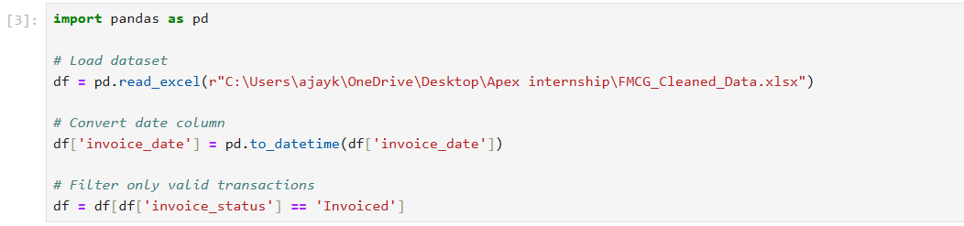

4. Hypothesis 1 — Frequency vs Spending

Business Question:
Do frequent customers spend more money?

Step 1: Create RFM Table
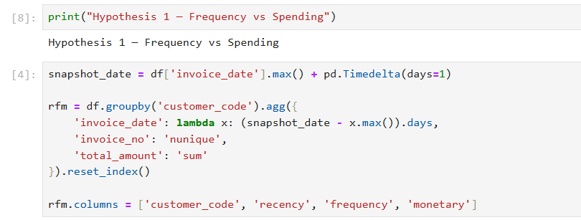

Step 2: Split Customers

Step 3: Perform T-Test
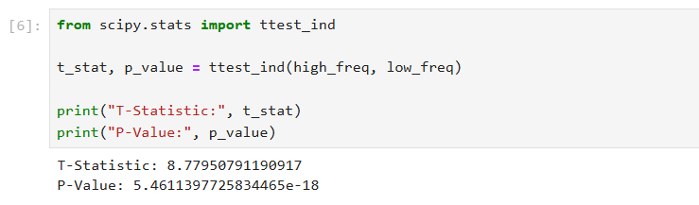

Step 4: Interpretation
- If p-value < 0.05 → Significant

Business Conclusion:
High-frequency customers spend significantly more.
Action: Focus on retention & loyalty programs

5. Hypothesis 2 — Credit vs Cash Customers

Business Question:
Do credit customers generate higher revenue?

Step 1: Split Data
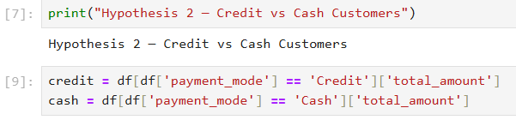

Step 2: Perform T-Test
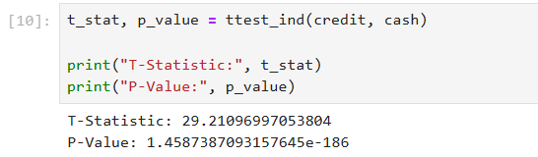

Step 3: Interpretation

Result:
- p-value < 0.05 → Significant

Business Meaning:
Credit customers generate more revenue.
But:
- Higher risk (delayed payments)
- Need credit control strategy

6. Hypothesis 3 — Monthly Revenue Variation

Business Question:
Does revenue significantly change across months?

Step 1: Extract Month
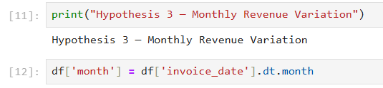

Step 2: Group Data
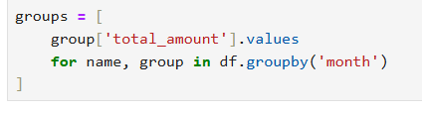

Step 3: Perform ANOVA Test
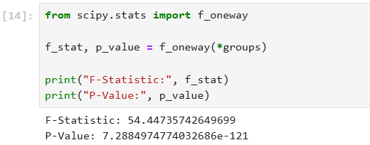

Step 4: Interpretation

Result:
- p-value < 0.05 → Significant

Business Meaning:
Revenue varies significantly across months.
Confirms seasonality
- Peak → Festive months
- Low → Off-season

7. Final Statistical Summary
Hypothesis | Result | Business Impact
Frequency vs Spending | ✅ Significant | Focus on loyalty
Credit vs Cash | ✅ Significant | Manage credit risk
Monthly Variation | ✅ Significant | Plan seasonal strategy

8. Key Takeaways
- All insights are statistically validated
- Business decisions are data-driven
- Results support:
  - Customer retention strategy
  - Credit policy optimization
  - Seasonal planning

